Supply Chain Summary Report

Key Insights :

- Furniture generated the highest total losses among all product categories.
- The Central region recorded the highest total losses, while the West region generated the highest overall profit.
- High discounts significantly reduce profitability. Orders with discounts above 50% resulted in negative profit in 100% of cases, while discounts between 21%–50% produced losses in 91% of orders.
- The five most profitable customers are Tamara Chand, Raymond Buch, Sanjit Chand, Hunter Lopez, and Adrian Barton.
- The Consumer segment is the most profitable customer segment, followed by Corporate, while Home Office is the least profitable.
- The Technology category has the highest return rate (8.45%), and the Machines sub-category records the highest return rate (11.30%).
- Profitability starts to decline at approximately a 30% discount level, suggesting that discounts should generally remain at 20% or below.

----------------------------------------------------------------------------------------------------

Dashboard Overview :
The dashboard was designed to provide an interactive analysis of supply chain Profitability through:
- KPI Cards (Total Revenue, Total Profit, Total Orders, Return Rate)
- Profit analysis by category, region, and customer segment
- Top profitable customers
- Return rate analysis by category and sub-category
- Discount impact on profitability
- Interactive slicers for dynamic filtering

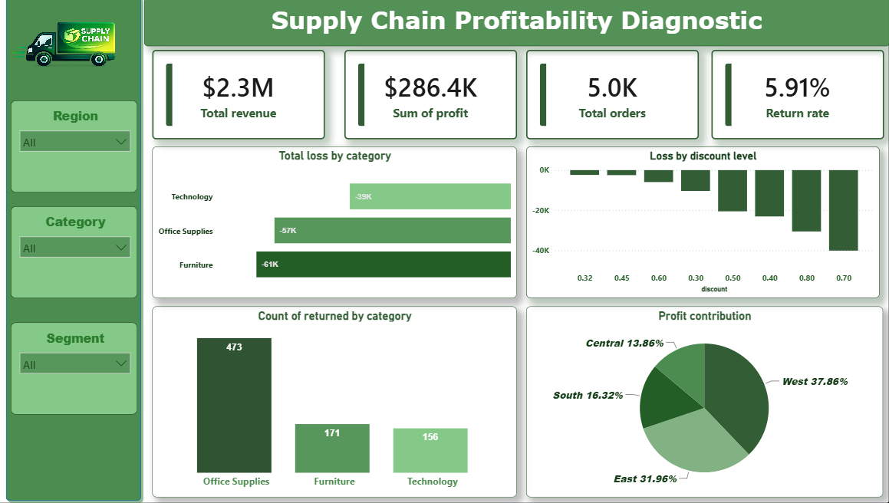

Recommendations :
- Limit standard discounts to 20% or below to maintain healthy profit margins.
- Review pricing and discount policies for orders receiving discounts above 30%.
- Investigate the high return rates in the Technology category, particularly the Machines sub-category.
- Develop improvement plans for the Central region to reduce losses and improve profitability.

